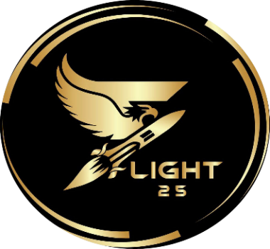

**FLIGHT’25 SCHEDULE**

**FN -** denotes Forenoon. Event starts at 09:00 am

**AN -** denotes Afternoon. Event starts at 01:00 pm

**Full day -** denotes that the participant will be engaged throughout the duration 09:00 am - 04:30 pm with a lunch break and other short breaks.

**Anytime -** denotes that the event is of short duration and the participant can start it any time between 09:00 am - 04:30 pm as per their convenience.

**Solo -** denotes that the registration is for an individual.

**Team -** denotes that the registration is for a team of a specified number of members.

Click on the event name for its description.

Go through the schedule carefully to avoid time clashes. Click below to pay and register.

REGISTER & APPLY

To register now, use the Google form below.

<https://forms.gle/UnTLA8iq8M9aWgQA7>

**Day 1: 05-04-20250**

|  |  |  |  |  |
| --- | --- | --- | --- | --- |
| **WORKSHOPS** | | | | |
| Composite | Day 1 & 2 | Full day | Solo | ₹300 |
| RC Plane Building | Day 1 & 2 | Full day | Team (1 to 4) | ₹ 2699 |
| Rocket Building | Day 1 | Full day | Solo | ₹ 600 |
| Avionics Workshop | Day 1 | Full day | Solo | ₹ 250 |
| Jet Handling | Day 1 | Full day | Solo | ₹ 400 |
| IC engine | Day 1 | Full day | Solo | ₹ 300 |
| Ansys | Day 1 | Full day | Solo | ₹ 300 |
| NDT (NON DESTRUCTIVE TESTING) | DAY 1 | Full day | Solo | ₹250 |
| 3D Printing Workshop | Day 1 | Full day | Solo | ₹600 |
| **TECHNICAL EVENTS** | | | | |
| Paper Presentation | Day 1 | Full day | Team (1 to 2) | ₹ 250 |
| Bottle Rocket | Day 1 | Anytime | Solo | ₹ 99 |
| Flight Simulators | Day 1 & 2 | Anytime | Solo | ₹ 200 |
| Drone Simulators | Day 1 & 2 | Anytime | Solo | ₹ 100 |
| Drone & Flight Simulators | Day 1 & 2 | Anytime | Solo | ₹ 250 |

**DAY 2 : 06-04-2025**

|  |  |  |  |  |
| --- | --- | --- | --- | --- |
| **WORKSHOPS** | | | | |
| Basics of Flight | DAY 2 | Full day | Solo | ₹299 |
| Drone workshop | DAY 2 | Full day | Solo | ₹800 |
| **TECHNICAL EVENTS** | | | | |
| RC Plane Competition | DAY 2 | Full day | Team (1 to 4) | ₹1500 |
| Drone Competition | DAY 2 | Full day | Team (1 to 3) | ₹1500 |
| Glider Competition | DAY 2 | Full day | Team (1 to 3) | ₹600 |
| Air crash Investigation | DAY 2 | Full day | Team (1 to 5) | ₹200 |
| Aero Design contest | DAY 2 | Full day | Solo | ₹300 |